|  |
| --- |
| For Registrar’s Use only |

Code # BU10 (2014)

**New Emphasis/Concentration or Option Proposal-Bulletin Change Transmittal Form**

**Undergraduate Curriculum Council** - Print 1 copy for signatures and save 1 electronic copy.

|  |
| --- |
| **New Certificate or Degree Program** (The following critical elements are taken directly from the Arkansas Department of Higher Education’s “Criteria and Procedures for Preparing Proposals for New Programs”.) Please complete the following and attach a copy of the catalogue page(s) showing what changes are necessary.*.* |

|  |  |
| --- | --- |
| ___________________ Enter date… **Department Curriculum Committee Chair** | ___________________ Enter date…  **COPE Chair (if applicable)** |
| ___________________ Enter date… **Department Chair:** | ___________________ Enter date…  **General Education Committee Chair (If applicable)** |
| ___________________ Enter date… **College Curriculum Committee Chair** | ___________________ Enter date…  **Undergraduate Curriculum Council Chair** |
| ___________________ Enter date… **College Dean** | ___________________ Enter date…  **Graduate Curriculum Committee Chair** |
|  | ___________________ Enter date…  **Vice Chancellor for Academic Affairs** |

**1. Proposed Program Title**

Bachelor of Science in Marketing, International Business Emphasis

**2. CIP Code Requested**

52.1403

**3. Contact Person** (Name, Email Address, Phone Number)

Dr. Melodie Philhours, [mphil@astate.edu](mailto:mphil@astate.edu), 870-680-8148

**4. Proposed Starting Date**

7/1/2015

**From the most current electronic version of the bulletin, copy all bulletin pages that this proposal affects and paste it to the end of this proposal.**

**To copy from the bulletin:**

1. Minimize this form.
2. Go to <http://registrar.astate.edu/bulletin.htm> and choose either undergraduate or graduate.
3. This will take you to a list of the bulletins by year, please open the most current bulletin.
4. Find the page(s) you wish to copy, click on the “select” button and highlight the pages you want to copy.
5. Right-click on the highlighted area.
6. Click on “copy”.
7. Minimize the bulletin and maximize this page.
8. Right-click immediately below this area and choose “paste”.
9. For additions to the bulletin, please change font color and make the font size larger than the surrounding text. Make it noticeable.
10. For deletions, strike through the text, change the font color, and enlarge the font size. Make it noticeable.

**MARKETING PROGRAM:**

The fundamental purpose of marketing is to create value for your customers. This purpose is fulfilled by both organizations and individuals in both profit and not for profit settings. Fulfilling this purpose requires the creation, communication and delivery of a product, service or idea so that exchange can take place. The major in marketing prepares students to plan and implement successful marketing strategies across a variety of industries. Elective concentration may be chosen in Marketing Management, International Business, or Logistics.

Page 154

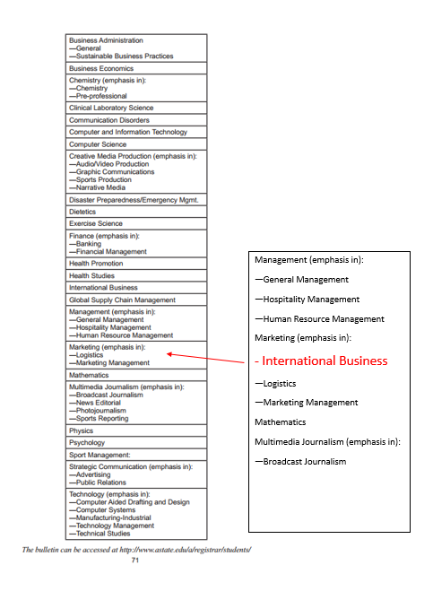

***INSERT AFTER PAGE 160 & BEFORE 161***

**Major in Marketing**

**Bachelor of Science**

**Emphasis in International Business**

|  |  |
| --- | --- |
| **University Requirements:** |  |
| See University General Requirements for Baccalaureate degrees (p. 41)  *(For College of Business requirements, see p. 132)* |  |
| **First Year Making Connections Course:** | **Sem. Hrs.** |
| BUSN 1003, First Year Experience Business | 3 |
| **General Education Requirements** | **Sem. Hrs.** |
| See General Education Curriculum for Baccalaureate degrees (p. 84)  **Students with this major must take the following:**  *MATH 2143, Business Calculus with a “C” or better.*  *ANTH 2233, Introduction to Cultural Anthropology OR*  *SOC 2213, Introduction to Sociology*  *ECON 2313, Principles of Macroeconomics*  *COMS 1203, Oral Communications (Required Departmental Gen. Ed. Option)* | **35** |
| **College of Business Core Courses:** | **Sem. Hrs.** |
| (See Beginning of Business Section) | **39** |
| **Major Requirements:** | **Sem. Hrs.** |
| MKTG 3023, Applied Research | 3 |
| MKTG 3163, Supply Chain Management | 3 |
| MKTG 4043, Consumer Behavior | 3 |
| MKTG 4083, Marketing Research Design and Analysis | 3 |
| MKTG 4223, Marketing Management | 3 |
| **Sub-total** | **15** |
| **Emphasis Area (International Business):** | **Sem. Hrs.** |
| MKTG 41133, International Marketing | 3 |
| ECON 4143, Export Policies & Procedures | 3 |
| FIN 3813, International Financial Management and Banking | 3 |
| MKTG 4133, International Logistics and Outsourcing | 3 |
| MGMT 4123, International Management | 3 |
| **Select one of the following:**  ECON 4103, International Trade  CIT 4453, Global E-Commerce  MGMT 3193, Social Impact Management  ECON 4363, Global Environmental Policies  IB 4133, International Law  IB 3013, Global Leadership  IB 4283, Internship in International Business Studies | 3 |
| **Sub-total** | **18** |
| **Electives:** | **Sem. Hrs.** |
| Electives | **10** |
| **Total Required Hours:** | **120** |

A complete 8-semester degree plan is available at <http://registrar.astate.edu/>.

**LETTER OF NOTIFICATION – 3  
NEW OPTION, CONCENTRATION, EMPHASIS**(Maximum 18 semester credit hours of new theory courses and 6 credit hours of new practicum courses)

1. Institution submitting request:

Arkansas State University, College of Business, Department of Management & Marketing

2. Contact person/title:

Dr. Melodie Philhours, Chair, Management & Marketing Department

3. Phone number/e-mail address:

870-680-8148/mphil@astate.edu

4. Proposed effective date:

Fall 2015

5. Title of degree program:

Marketing, International Business Emphasis, B.S.

6. CIP Code:

52.1403

7. Degree Code:

2860

8. Proposed option/concentration/emphasis name:

International Business Emphasis

9. Reason for proposed action:

Global issues impact many businesses. This program is designed to prepare students for marketing positions both domestic and abroad, in local organizations as well as worldwide. In addition to the core marketing curriculum, students who seek the IB emphasis will have training uniquely qualifying them to secure professional positions developing marketing strategies for international markets or international market segments in the U.S. as well as managing supply chains that include international vendors.

10. New option/concentration/emphasis objective

The objective of the Marketing, International Business Emphasis is to provide students with a strong and specific skill, marketing, along with more general international business knowledge in economics, finance, management, and logistics. This combination of course work will deliver marketing theory combined with international business knowledge needed to practice marketing with an international company, an international target market, or to guide marketing strategy in multinational organizations both for-profit and non-profit.

**11. Provide the following:**

a. Curriculum outline - List of required courses

FYE & General Education Courses – 38 hours

College of Business Core Courses – 39 hours

Electives – 10 hours

Marketing Core Courses – 15 hours

MKTG 3023 – Applied Research

MKTG 3163 – Supply Chain Management

MKTG 4043 – Consumer Behavior

MKTG 4083 – Marketing Research

MKTG 4223 – Marketing Management

International Business Emphasis Courses –18 hours

MKTG 4113, International Marketing

ECON 4143, Export Policies & Procedures

FIN 3813, International Financial Management and Banking

MKTG 4133, International Logistics and Outsourcing

MGMT 4123, International Management

*Select one of the following:*

ECON 4103, International Trade

CIT 4453, Global E-Commerce

MGMT 3193, Social Impact Management

ECON 4363, Global Environmental Policies

IB 4133, International Law

IB 3013, Global Leadership

IB 4283, Internship in International Business Studies

b. New course descriptions

No new courses are required.

c. Program goals and objectives

The objective of this program is to prepare graduates for careers in marketing in organizations both domestic and international through the discovery, analysis, application and creation of marketing strategies designed for international markets and the impact of international markets and competitors upon organizations.

d. Expected student learning outcomes

Students in this program should be able to demonstrate knowledge and skills in the following areas:

1. Business Knowledge – both general and specific to this emphasis area

2. Written and Oral Communication

3. Technology Used Effectively

4. Ethical Decision Making

5. Intercultural/Diversity Perspectives

12. Will the new option be offered via distance delivery?

No

13. Mode of delivery to be used:

Mode of delivery will vary according to course and will include lecture, independent research, and internships.

14. Explain in detail the distance delivery procedures to be used:

None

15. Is the degree approved for distance delivery?

No

16. List courses in option/concentration/emphasis. Include course descriptions for new courses.

International Business Emphasis Courses –18 hours

MKTG 4113, International Marketing

ECON 4143, Export Policies & Procedures

FIN 3813, International Financial Management and Banking

MKTG 4133, International Logistics and Outsourcing

MGMT 4123, International Management

Select one of the following:

ECON 4103, International Trade

CIT 4453, Global E-Commerce

MGMT 3193, Social Impact Management

ECON 4363, Global Environmental Policies

IB 4133, International Law

IB 3013, Global Leadership

IB 4283, Internship in International Business Studies

17. Specify the amount of the additional costs required, the source of funds, and how funds will be used.

At current enrollment levels no additional costs are needed. All of these courses are currently being taught in support of the International Business and various other majors within the College of Business, albeit most with only one section. When demand for the emphasis area grows, as anticipated, additional faculty may be needed to offer additional sections of these courses.

|  |  |
| --- | --- |
| **President/Chancellor Approval Date:** Enter date... | ___________________ Enter date…  **Vice Chancellor for Academic Affairs** |
| **Board of Trustees Notification Date:**  Enter date... |